Isabella
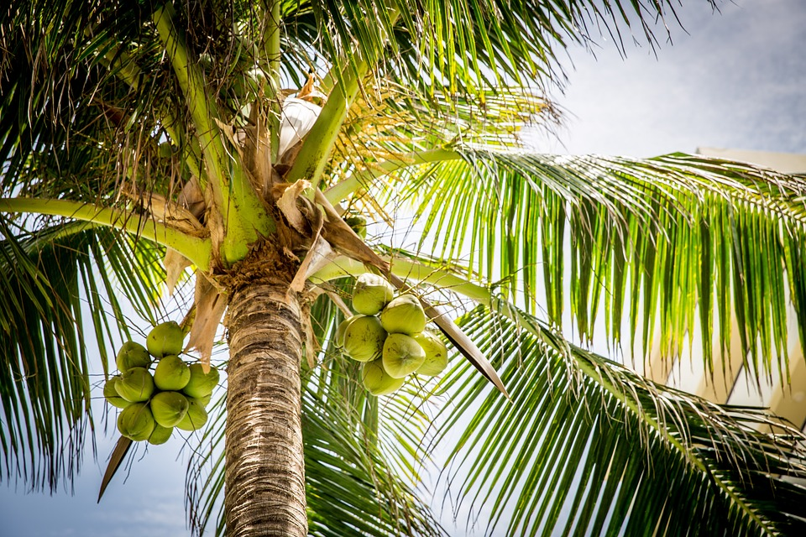

This book is decided to my family because they care for me.

I stepped onto my front porch and the bright sunlight hit my face. I looked down at my packed car. In the car there were suitcases, my stuffed bear, and my baby pictures. Today I was moving into a different house in California. I was not that scared of what my new house looked like. It was my new school that terrified me.
As I slide into the car I wondered what my school looked like and if I would make any friends.
My dad started the rusty car. I rolled down my window and a gust of cold air blew in. We waved good-bye to our house and our front yard and we were off. I stared out the window once again to gaze at the beautiful mountain views of Nevada. Soon I got tired and fell asleep. A long while later we were in California.
When we got to our new house I jumped out of the car and ran onto the front porch. Quickly my dad unlocked the door. “Creak” went the door. I stepped inside and dust fell in my eyes.
“Here we are!” my dad reported. The house looked spooky and wrecked. “Looks like we are going to have to do a lot of fixing,” reported my dad.
“Yeah,” I said with disappointment in my voice
“Looks like we are going to have to sleep in a hotel tonight” my dad whispered to my mom.
So we drove to the hotel. When we got there it was past 10:00 pm. The hotel clerk at the front desk told us our room number and handed us the key. A short while later we got to the room. We flicked on the light and brushed our teeth. The water was cold. It reminded me of the time my family and I went to Canada. Soon after, we brushed our teeth we flicked off the light and went to sleep.
The next day, I woke up, jumped out of bed, and threw on some clothes. It was here… the first day of school. I kissed my mom and dad good-bye then ran out the door to catch the bus. “Wait, wait!” I screamed. All of a sudden the bus driver saw me in his mirror and flung the doors open once again. Then he helped me onto the bus.
“What is your name?” asked the bus driver. “Isabella” I answered. “Oh, Isabella that’s a beautiful name!” said the bus driver. “Thank you” I beamed as I walked to the back of the bus. In the back of the bus I saw a girl sitting all by herself, looking lonely.
“Hi,” I beamed. “What's your name?”
“I’m Taylor” the girl quietly said. “I’m new”
“So am I” I almost shouted. As I sat next to her I asked her “Where do you live?”
“1791 cedar street” answered Taylor.
“Wait,” I respond.
“Do you live in that big white house”
“Yes,” answered Taylor in amazement.”
As we talked we realized that we had a lot of classes together. Music, science, and art would all be a class that we were both in. We have a lot in common I thought. For the rest of the bus ride we talked and talked.

Once we got to school we ran to are first class together. We ate lunch together and we ran to the bus stop together. At the end of the day we sat next to each other on the bus. We said goodbye to each other. When I got home I knew that I had started a friendship with Taylor and that friendship will never end.

